**IOT THEFT DETECTION DEVICE**

by

ANIL M 19BPS1047

SURYA PRAKASH 19BPS1052

HANUMAN SAI 19BPS1066

VIJAY G 19BPS1078

A project report submitted to

**Dr. Florence Gnana Poovathy J**

**SCHOOL OF ELECTRONICS ENGINEERING**

in partial fulfilment of the requirements for the course of

**CSE2010 – COMMUNICATION FOR CPS**

in

**B. Tech. COMPUTER SCIENCE AND ENGINEERING**



**Vandalur – Kelambakkam Road**

**Chennai – 600127**

**NOVEMBER 2020**

**BONAFIDE CERTIFICATE**

Certified that this project report entitled “**IOT THEFT DETECTION DEVICE”** is a Bonafide work of ANIL M 19BPS1047, SURYA PRAKASH 19BPS1052, HANUMAN SAI 19BPS1066, VIJAY G 19BPS1078 **who** carried out the Project work under my supervision and guidance for **CSE2010- COMMUNICATION FOR CPS.**

**Dr. Florence Gnana Poovathy J**

Associate Professor

School of Electronics Engineering (SENSE),

VIT University, Chennai

Chennai – 600 127.

**ABSTRACT**

This project is about the development of an Internet of Things (IoT) based smart wireless home security system, which sends an alert on intrusion. A PIR sensor is used to detect the motion of any human being in its vicinity. NODE MCU ESP8266 is used to connect the system to internet through Wi-Fi. Whenever a movement is detected by the PIR sensor, a message is sent to a smart phone by the NODE MCU.

* Keyword: NODE MCU ESP8266, PIR Sensor, Blynk App, Arduino IDE

**ACKNOWLEDGEMENT**

We wish to express our sincere thanks and deep sense of gratitude to our project guide, **Dr. FlorenceGnanaPoovathy J,** Associate Professor, School of Computer Science and Engineering, for her consistent encouragement and valuable guidance offered to us in a pleasant manner throughout the course of the project work.

We are extremely grateful to **Dr. Neela Narayanan,** Dean of School of Computer Science and Engineering, VIT Chennai, for extending the facilities of the school towards our project and for his unstinting support.

We also take this opportunity to thank all the faculty of the school for their support and their wisdom imparted to us throughout the course.

We thank our parents, family, and friends for bearing with us throughout the course of our project and for the opportunity they provided us in undergoing this course in such a prestigious institution.

**NAME WITH SIGNATURE NAME WITH SIGNATURE**

**TABLE OF CONTENTS**

|  |  |  |  |
| --- | --- | --- | --- |
| **SERIAL NO.** |  | **TITLE** | **PAGE NO.** |
|  |  | ABSTRACT |  |
|  |  | ACKNOWLEDGEMENT |  |
|  |  |  |  |
| 1 |  | INTRODUCTION |  |
|  |  |  |  |
|  | 1.1 | OBJECTIVES AND GOALS |  |
|  | 1.2 | APPLICATIONS |  |
|  | 1.3 | FEATURES |  |
|  |  |  |  |
| 2 |  | DESIGN |  |
|  | 2.1 | BLOCK DIAGRAM |  |
|  | 2.2  2.3 | HARDWARE ANALYSIS  (SNAPSHOTS-PROJECT, TEAM, RESULTS) |  |
|  |  |  |  |
| 3 | 3.1 | SOFTWARE –CODING AND ANALYSIS |  |
|  |  | (SNAPSHOTS OF CODING AND RESULTS) |  |
| 4 |  | CONCLUSION AND FUTURE WORK |  |
|  | 4.1 | RESULT, CONCLUSION AND INFERENCE |  |
|  | 4.2 | FUTURE WORK  COST |  |

5 REFERENCES

6 PHOTO GRAPH OF THE PROJECT ALONG WITH THE TEAM MEMBERS

1. **INTRODUCTION**
   1. **OBJECTIVES AND GOALS**

IERC defines IoT as "The Internet of Things allows people and things to be connected Anytime, Anyplace, with Anything and Anyone, ideally using Any path/network and Any service.". Number of connected IoT devices is increasing exponentially worldwide and it is expected to reach 75 billion by 2025. IoT has wide spread application in many fields of engineering in providing real time data and real time decisions and controlling the connected devices seamlessly in real time. IoT (Internet of Things) is the environment in which physical items interact with each other and user–to–computer communications, machine – to- machine communications are enabled and this communication is extended to “things”.

|  |  |
| --- | --- |
| 1.2 | APPLICATIONS |

Security is one of the useful applications of IoT. Intrusion detection is one of the challenges in home security. The common type of security system uses CCTV cameras and image processing and we are using it to create an inexpensive security system for homes as well as industrial use. The IoT network consists of embedded electronics, sensors and software from their home, they want to be assured that their home is protected by intruders and thieves while they are gone. This is why the proposed system keeps the owner informed in the real time about the security status of their home. With the tendency of house safety protection, the detecting

|  |  |
| --- | --- |
| 1.3 | FEATURES |
|  |  |

**2 . DESIGN**

**2.1 BLOCK DIAGRAM:**

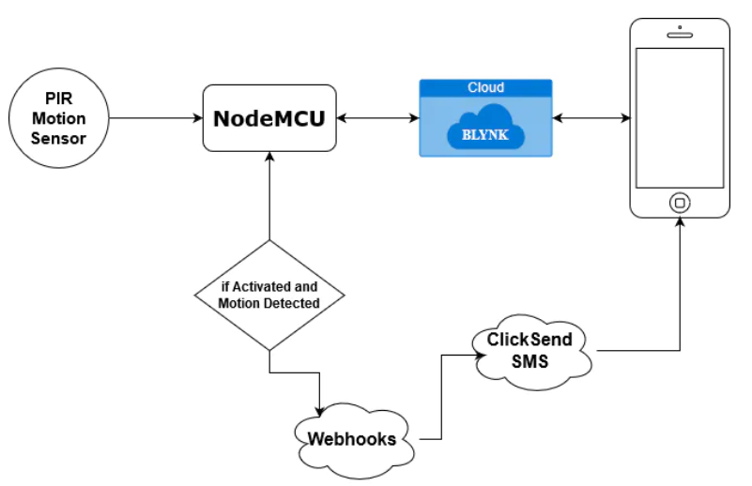

**2.2. HARDWARE ANALYSIS:**

**I. PIR MOTION SENSOR**

PIR sensors allow you to sense motion, almost always used to detect whether a human has moved in or out of the sensors range. They are small, inexpensive, low-power, easy to use and don't wear out. For that reason, they are commonly found in appliances and gadgets used in homes or businesses. They are often referred to as PIR, "Passive Infrared", "Pyroelectric", or "IR motion" sensors.

PIRs are basically made of a [pyroelectric sensor](http://en.wikipedia.org/wiki/Pyroelectric) which can detect levels of infrared radiation. Everything emits some low-level radiation, and the hotter something is, the more radiation is emitted. The sensor in a motion detector is actually split in two halves. The reason for that is that we are looking to detect motion (change) not average IR levels. The two halves are wired up so that they cancel each other out. If one half sees more or less IR radiation than the other, the output will swing high or low.

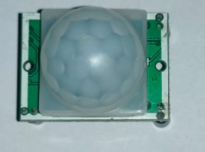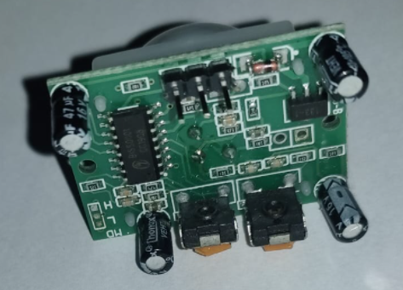

1. **Node MCU**

Node MCU is an open-source [LUA](https://www.lua.org/start.html)based firmware developed for ESP8266 Wi-Fi chip. By exploring functionality with ESP8266 chip, Node MCU firmware comes with ESP8266 Development board/kit i.e., Node MCU Development board.

Since Node MCU is an open-source platform, its hardware design is open for edit/modify/build.

Node MCU Dev Kit/board consist of ESP8266 Wi-Fi enabled chip. The **ESP8266** is a low-cost [Wi-Fi](https://en.wikipedia.org/wiki/Wi-Fi)chip developed by Espress if Systems with TCP/IP protocol. For more information about ESP8266, you can refer to [ESP8266 WiFi Module.](http://www.electronicwings.com/sensors-modules/esp8266-wifi-module)

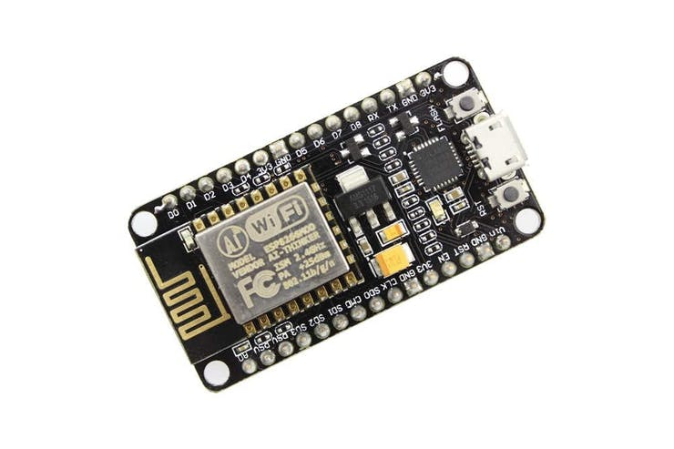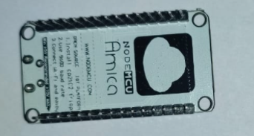

Node MCU Development Board/kit v1.0 (Version2)

**3.BreadBoard**

A breadboard is a rectangular plastic board with a bunch of tiny holes in it. These holes let you easily insert electronic components to prototype (meaning to build and test an early version of) an electronic circuit, like this one with a battery, switch, resistor, and an LED (light-emitting diode).

**4.Jumper Wires**

Jumper cables is a smaller and more bendable corrugated cable which is used to connect antennas and other components to network cabling.

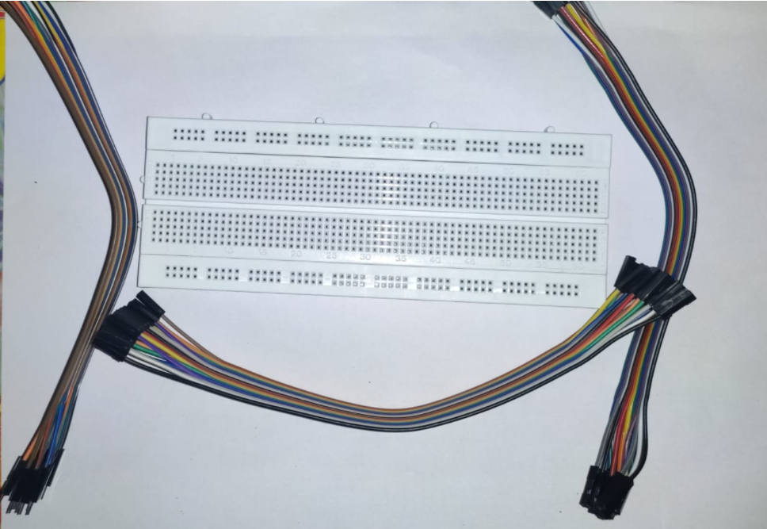

BREAD BOARD AND JUMPER WIRES

**2.3. SNAP SHOTS-PROJECT, TEAM, RESULTS**

**IFTT SNAP SHOTS:**

**GIVING CONNECTION TO COMMUNICATE**

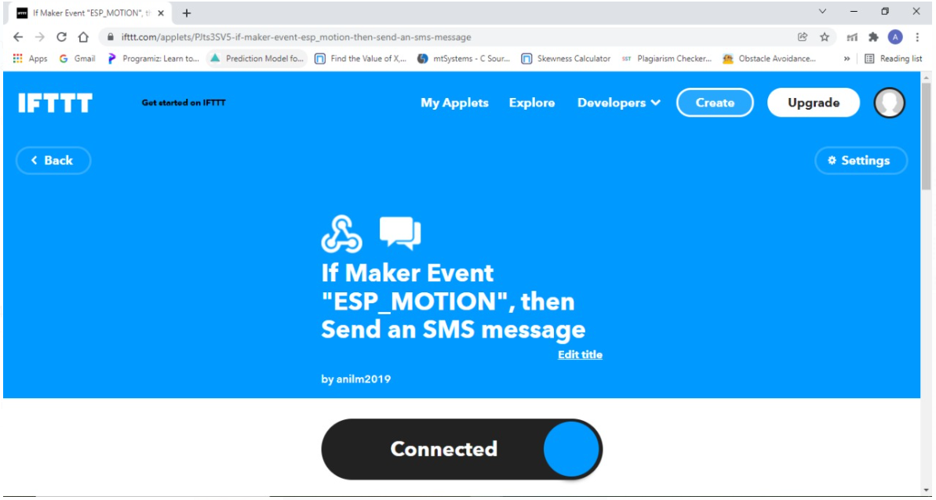

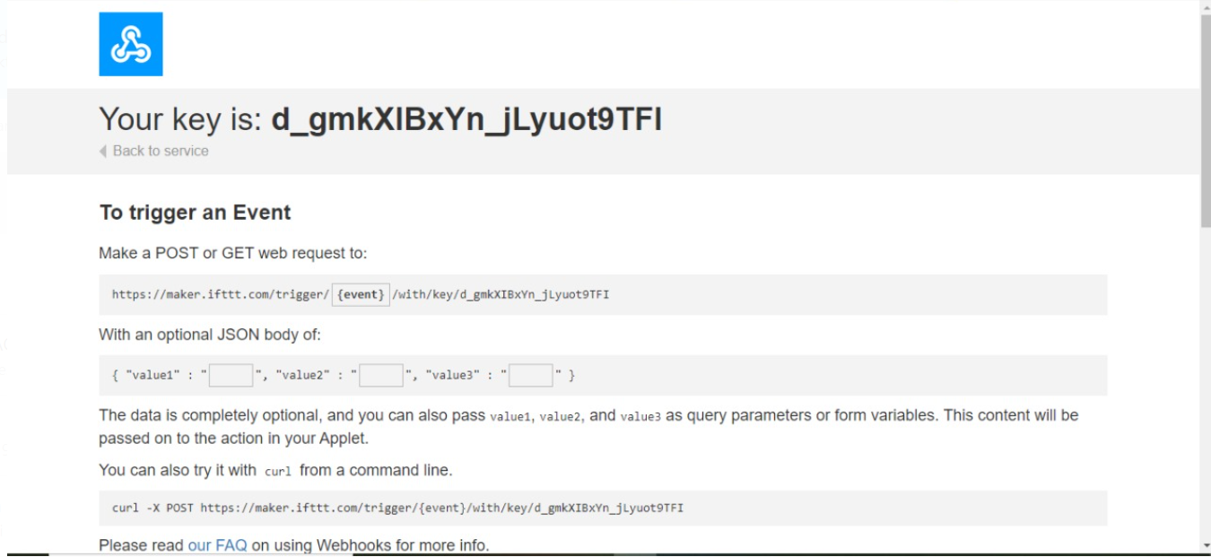

ADDING OUR EVENT NAME AS ESP_MOTION



ADDED OUR MOBILE NUMBER:

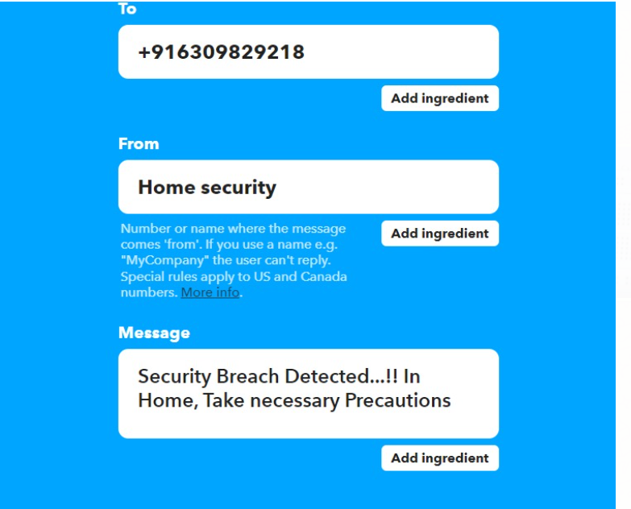



THE FINAL RESULT TO THE OWNER MOBILE WHEN THE PIR SENSOR SENSES THE MOTION:

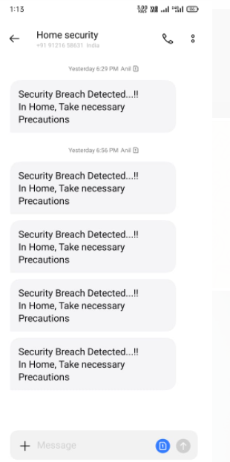

|  |
| --- |
| **3.1 . SOFTWARE –CODING AND ANALYSIS** |
| **(SNAPSHOTS OF CODING AND RESULTS)**  **ARDUINO CODING PART** |

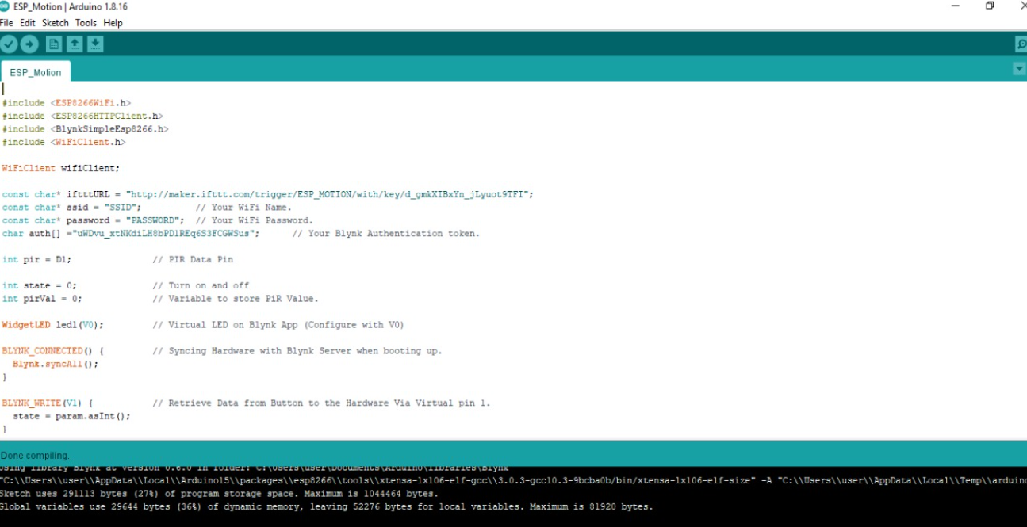

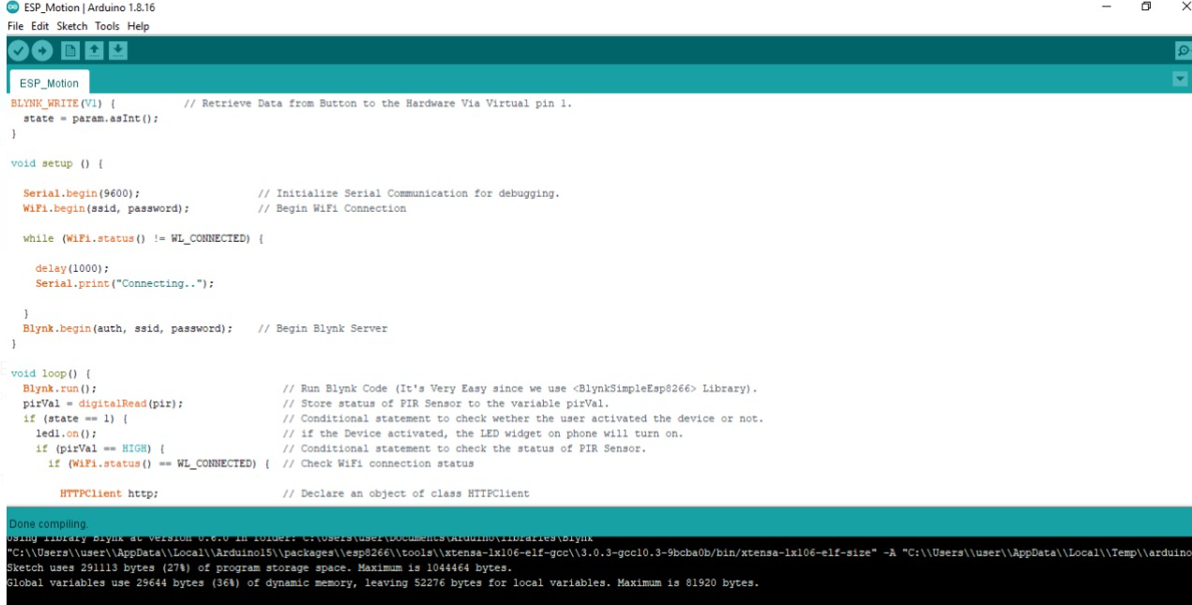

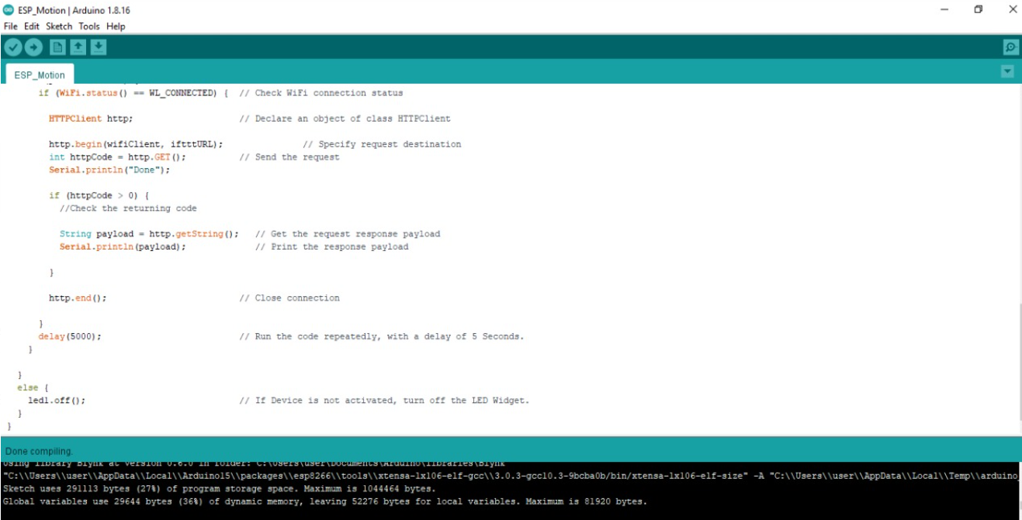

**4.CONCLUSION AND FUTURE WORK**

**4.1 - RESULT, CONCLUSION AND INFERENCE**

The sensors placed on the door inform the home owner as soon as the door is opened by sending a Push notification. The user will get this notification irrespective of whether the phone is locked or unlocked or even if any other app is opened at the moment. This was the main objective of the project. This setup can also be used in commercial offices where some areas are restricted for certain personnel, such a system will immediately inform the administrator of any unauthorized personnel trying to access such an area. The developed system can also be used to in industrial and commercial applications such as offices, warehouses and other areas where some areas are reserved for authorized personnel only or other places where safety and precautions are of primary concerns such as internet server room of a big MNC from where corporate data can be stolen. The system can also be easily upgraded to add extra safety features such as cameras for increased safety. The system can also further be developed by adding an RFID scanner so that the authorized users need only carry a RFID or NFC tag with them on their person. The RFID scanner will work by scanning the tag wirelessly and if the user is authorized to enter, the alarm system will be disabled for some time so that the user can enter.

**REFERENCES**

**INTERNATIONAL JOURNALS**

1. P. Guillemin and P. Friess, “Internet of things strategic research roadmap,” The Cluster of European Research Projects, Tech. Rep., September <http://www.internet-of-thingsresearch.eu/pdf/IoT_Cluster_Strategic_Research_Agenda_2009.pdf>
2. Kyoung Nam Ha1, Kyung Chang Lee2, Suk Lee3 Department of Mechanical and Intelligent Systems Engineering, Pusan National University, Busan, Korea “Development of PIR sensor based indoor location detection system for smart home”.
3. Yong Tae Park, Pranesh Stha pit, Jae-Young Pyun, “Smart Digital Door Lock for the Home Automation”, IEEE, pp. 1-6, TENCON 2009
4. Vinay Sagar K and Kusuma S, Home Automation Using Internet of Things, International Research Journal of Engineering and Technology, Volume 2, Issue 3 on pp. 1965 1970, June 2015.
5. Anitha A, Kalra S and Shrivastav 2016 A Cyber defence using artificial home automation system using IoT International Journal of Pharmacy and Technology 25358-64.
6. Jayashri B and Arvind S 2013 Design and Implementation of Security for Smart Home based on GSM technology International Journal of Smart Home 7 201-08
7. Yong Tae Park, Pranesh Sthapit, Jae-Young Pyun, “Smart Digital Door Lock for the Home Automation”, IEEE, pp. 1-6, TENCON 2009

**INTERNATIONAL CONFERENCES**

1. Syafaah, L.Minarno, A. E.Sumadi, F. D. S., & Rahayu, D. A. P. (2019). ESP 8266 For Control and Monitoring in Smart Home Application. 2019 International Conference on Computer Science, Information Technology, and Electrical Engineering (ICOMITEE). doi:10.1109/icomitee.2019.8921287 .
2. Vishwajeet Hari Bhide, Ranjeev Wagh,” I-Learning lot: An Intelligent Self Learning System for Home Automation Using lot”, International Conference on Communication and Signal Processing, pp. 1763-1767, 2015
3. Lee C T, Shen T C, Lee W D and Weng K W 2016 A novel electronic lock using optical Morse code based on the Internet of Things Proceedings of the IEEE International Conference on Advanced Materials for Science and Engineering eds. Meen, Prior & Lam.
4. R. Teymour Zadeh, Salah Addin Ahmed, Kok Wai Chan and Mok Vee Hoong, "Smart GSM based Home Automation System," Systems, Process & Control (ICSPC), 2013 IEEE Conference on, Kuala Lumpur, 2013, pp. 306-309.

**REFERENCE JOURNALS:**

1. Yue Jīn, Zengshan Tian, Mu Zhou, Senior Member, IEEE, Ze Li, Zhen yuan Zhang a Whole-Home Level Intrusion Detection System using Wi-Fi-enabled IoT.
2. B. R. Pavithra, D., “ Iot-based monitoring and control system for home automation,” pp. 169 – 173, April 2015.
3. Ravi Kishore Kodali, Vishal Jain, Suva deep Bose and Lakshmi Boppana. “IoT Based Smart Security and Home Automation System. 1286-1289, 2016.
4. Kodali, R. K., & Mahesh, K. S. (2017, September). Low-cost implementation of smart home automation. In Advances in Computing, Communications and Informatics (ICACCI), 2017 International Conference on (pp. 461-466). IEEE

**BIODATA**

Name :

Mobile Number :

E-mail :

Permanent Address:

Name :

Mobile Number :

E-mail :

Permanent Address:

Name :

Mobile Number :

E-mail :

Permanent Address:

Name :

Mobile Number :

E-mail :

Permanent Address: